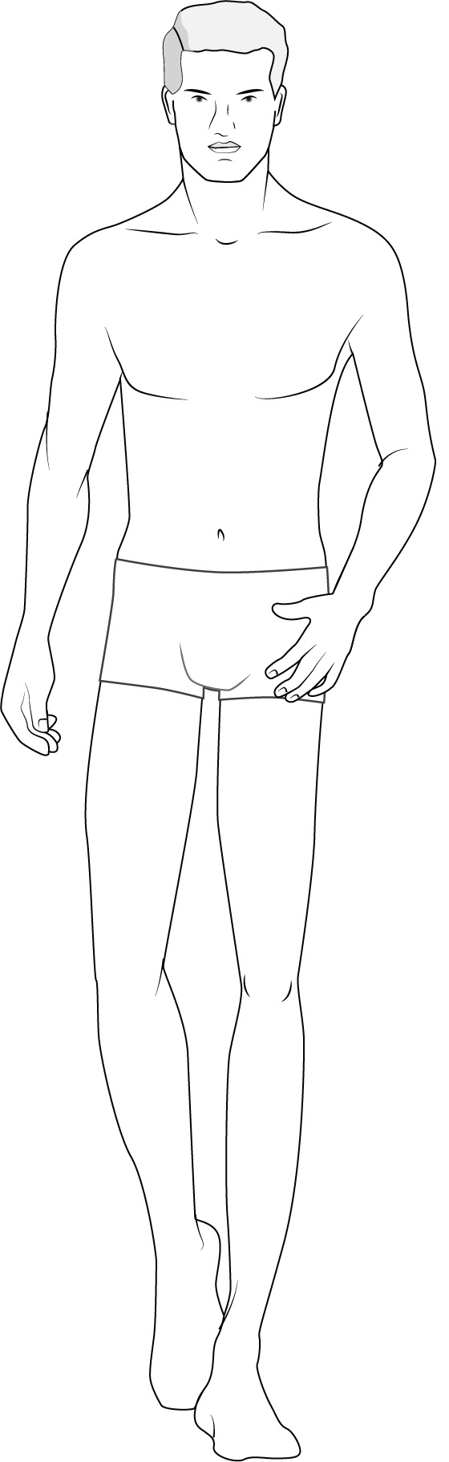
https://www.designersnexus.com/terms-of-service/

